Non-Executive Director
Application Pack

People and Organisational Development

Contents
Foreword 3
1. The Opportunity 4
1.1 The Role 4
2. About Us 5
2.1 Our strategic plan 5
2.2 Our vision and values 6
2.3 Corporate Objectives – 2022/23 7
2.4 Challenge and Context 7
2.5 Summary of Performance 8
2.6 Workforce 8
3. Board Committee Structure 11
4. About Stockport 12
5. Role specification 13
5.1 Person specification 15
6 Other Information 17
6.1 Time commitment 17
6.2 Induction and Training 17
6.3 Remuneration 17
6.4 Appointment, tenure and termination of office 17
6.5 Criteria for Disqualification (Including Fit and proper Persons Test) 18
6.7 Criteria for eligibility for appointment as a member of the Board of Directors 18
6.8 Checks with the Disclosure and Barring Service (DBS) 19
6. Applying for the role 19
7. Diversity and Monitoring 20

Foreword

Thank you for your interest in applying to become a Non-Executive Director at Stockport NHS Foundation Trust. This is an exciting time to consider a Non-Executive role within our organisation.

Our mission is “Making a difference every day” Through our engagement work to develop new values for the Trust, it was clear that, for many, the most important aspect of working here and of working in the NHS is to be able to make a difference to people’s lives.

Through the development of the Trust’s Strategy it is hoped that every member of staff will understand the mission of our organisation is to make a difference every day; whether this is a nurse delivering vital community services, a doctor performing life changing surgery, a health care assistant caring for an ill patient and their family, a porter making sure that patients are moved safely from one part of the hospital to another.

We aim to motivate colleagues throughout the Trust to see what needs to be done and take ownership for delivering on what we say we’re going to do. We aim to give people the confidence to take the responsibility their role gives them and make decisions for themselves within a framework of accountability and responsibility.

I hope you will consider applying for a role with us, and I look forward to meeting candidates whose ambitions and values support ours.

Professor Tony Warne,
Chair, Stockport NHS Foundation Trust

The Opportunity

We are looking for a Non-Executive Director to join our Board. This is an exceptional opportunity to join a forward thinking, innovative, friendly organisation with whom you can share your talents and expertise to make a positive difference to the lives of those served by our Trust. We are seeking an individual whose expertise/experience reflects a background in developing people and organisations. We are looking for people who understand and are committed to the developing a positive culture one that supports our strategy of “Making Stockport Foundation Trust a great place to work” , we are seeking someone who is passionate about making a positive difference. You will need to be a strong leader with a strategic perspective, and you should be committed to the principles of operating as part of a unitary Board.

We believe that the best boards are those that reflect the communities they serve. We are therefore seeking to improve the diversity of our Board to make it truly representative of our workforce and local population. We are committed to equality of opportunity for all, and appointments are based on merit.

We are keen to receive applications from all protected characteristics and those who either have a strong connection to their local community or those with lived experience, either as carers or service users. We would particularly welcome applications from black, Asian and minority ethnic communities and individuals with a disability, people who we know are under-represented in chair and non-executive roles.

1.1 The Role

You will need to have a genuine commitment to patients and the promotion of excellent health care services. You will need to demonstrate you can use your experience to:

- Work alongside other non-executives and executive colleagues as an equal member of the board

- Bring independence, external perspectives, skills and challenge to strategy development

- Hold the executive to account by providing purposeful, constructive scrutiny and challenge

- Shape and actively support a healthy culture for the Trust

A full role description and person specification can be found towards the end of this document on pages 13-15.

About Us
Stockport NHS Foundation Trust is no ordinary Trust. It holds a unique position in the Stockport community as the provider of healthcare to its population, and it is one of its largest employers. It offers a number of specialist services, including our highly rated stroke service, and plays a key partnership role within Greater Manchester, Stockport and East Cheshire.

We offer a number of specialist services and play a key partnership role with Greater Manchester, Stockport and East Cheshire. With an annual budget of around £300 million and about 5,000 staff we provide healthcare for residents in Stockport, East Cheshire and North Derbyshire as well as patients we treat from other boroughs in Greater Manchester who choose our services. The marked variation in deprivation across the area we serve – one of the five most polarised populations in England in terms of health and wealth – has an impact on the health and care needs of local people. While the health of the local population is generally improving many people are living with one or more long term condition, such as diabetes or dementia.

We are also seeing advances in healthcare, which mean we can care for people who would previously have been untreatable, and as a result are living longer. However, they are increasingly frail and need more health and social care support.

We employ around 5,200 staff, working in our hospital and community services to support people in their own homes.
Our main sites are:

- Stepping Hill Hospital,
- The Meadows,
- Bluebell,
- Swanbourne Gardens,
- The Devonshire Centre.

2.1 Our strategic plan

The Trust Strategy 2020/25 includes five strategic objectives. Each has a number of sub objectives, improvement measures and details of how we will monitor these. Each reflects our intention to continue as an integrated, acute and community provider of services.

Our five strategic objectives are:

  - A great place to work
  - Always learning, continually improving
  - Helping people live their best lives
  - Investing for the future, using our resources well
  - Working with others for our patients and communities.

Further information can be found in our Trust Strategy 2020-2025

2.2 Our vision and values

Our Values

The values of Stockport define who we are, what we believe and how we will work to deliver high quality care to ensure the best outcomes for our patients. Our values form a central part of our working culture and help to support the care we provide for patients and the community. Our values are:

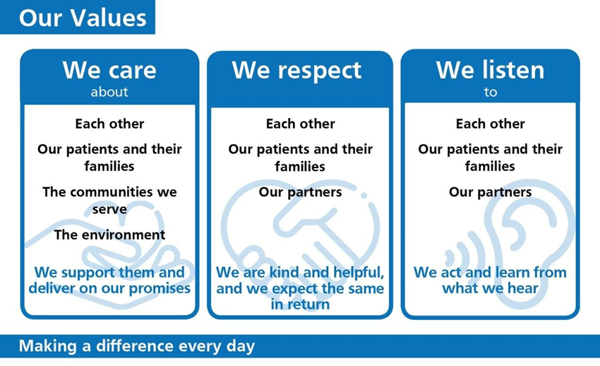

2.3 Corporate Objectives – 2022/23

In seeking to achieve our vision, we have set ourselves a number of objectives which help to define what success for the organisation will look like over the coming year. These objectives cover ‘business as usual’ – continuing to provide high quality care to people in our area – as well as transformational objectives which will help us to achieve the aspiration of a new integrated approach to health and care which better meets the needs of the local population. These are the specific priorities of the organisation for 2022/23, but they will also support the longer-term transition to a new approach to health, care and wellbeing in Stockport.

The key objectives of Stockport NHS FT are:
- Deliver safe accessible and personalised services for those we care for
- Support the health and wellbeing needs of our communities and staff
- Develop effective partnerships to address health and well-being inequalities
- Drive service improvement, through high quality research, innovation and transformation
- Develop a diverse, capable and motivated workforce to meet future service and user needs
- Utilise our resources in an efficient and effective manner
- Develop our Estate and digital infrastructure to meet service and user needs

2.4 Challenge and Context

Ensuring there are sufficient staff with the right skills and experience is an ongoing challenge for many NHS organisations, and it is one that rightly concerned our Board of Directors during 2021-22.

We have taken positive steps forward in recruiting to some traditionally difficult to fill consultant roles, and we have continued to invest in the recruitment of international nurses, health care assistants, and nurse associate roles. That investment in our workforce will continue into 2022-2023 as our Board has recently approved a £5.4m business case following a review of ward staffing.

Following an external review of the management of the organisation’s ageing estate and delivery of its estates and facilities services in 2019-20, we continued to closely monitor the delivery of a comprehensive action plan. We also agreed a plan to address the previous under investment in our estate and equipment.

During 2020-21 we spent over £24m on capital investments to make changes to some of our estate in response to the pandemic, as well as upgrade parts of Stepping Hill Hospital to standards expected of a modern hospital, such as the development of a new CT building.
We developed an outline business plan for the £30.6m emergency care campus and we hope to start work on this significant development later this year, subject to feedback from the Department of Health and Social Care and approval of a final business plan.

2.5 Summary of Performance

We are committed to providing the highest quality and safest care for patients, as well as contributing to the health and wellbeing of the people we serve. Our performance is examined critically so that we can build on good practice and keep on learning. Achieving key national and local clinical and performance standards is a priority as the visible measurable of the quality of our services.

Like many other NHS organisations we face challenges in consistently achieving these standards, and our performance has followed national trends, but our aim is always to improve.

Thanks to the efforts of the whole health and social care system we managed to cope with the demands of Covid-19, and while some services were able to continue almost as normal many others were impacted, resulting in a backlog of patients now waiting for diagnostic tests and treatment. We are working with trusts across GM to address that backlog, prioritising the patients most in need as well as those who have waited the longest to be seen.

2.6 Our People

Our People Strategy (2021-2023) outlines its organisational development priorities, through the implementation of systematic approaches.

We believe that valuing and developing an engaged workforce through compassionate leadership will enable us to make Stockport a great place to work.

We are committed to improving the experience of our staff with a protected characteristic.

Our Equality Diversity and Inclusion (EDI) Strategy 2022-2025 has been devised specifically focusing on the development of our workforce, following the evidence from our Workforce Race Equality Standard (WRES) Workforce Disability Equality Standard (WDES) Gender Pay Gap (GPG) and results from the NHS Staff Survey 2020. These collective metrics show that inequalities exist for our staff with protected characteristics, reporting higher levels of poorer experience, including harassment, bullying or abuse at work; greater inequalities in access to employment, development, and progression; lack of equitable representation across entry, middle and senior level roles and lack of diversity in leadership positions.

To this end, our focus for 2022/25 will be on the delivery of four key aims:
1. Current employees and future talent with protected characteristics are offered equality of opportunity and fair access to jobs, development and career progression
2. Employees with protected characteristics are enabled to work free from discrimination and bullying and harassment, in an inclusive work environment that embraces diversity
3. Current employees and future talent with protected characteristics are enabled into leadership positions, to drive lived experience into the heart of decision-making and to ensure services are designed, developed and delivered with inclusivity
4. We are compliant with our responsibilities under the relevant legislation and our data and resulting reports are consistent and accessible, as are the calculation and data analysis methodologies

Whilst our strategy focuses on targeted improvements with WRES, WDES and GPG, we include as appropriate, all protected characteristics and vulnerable groups in our approach, workforce development activities and delivery of services.

Details of our WRES and WDES can be found on the Trust’s website.

Board Committee Structure

About Stockport

Stockport has a population of 291,045 residents, with 313,610 people registered at one of Stockport’s 37 GP Practices. The population is growing by around 1,000 people a year and is expected to continue to grow at this rate over the life-span of this strategy. Overall, Stockport is one of the healthiest places to live in Greater Manchester, and the wider North West, with health outcomes broadly in line with national averages. Rates for deaths from cardio-vascular disease, road injuries, childhood obesity and physical activity in adults are all better than national averages. However, rates of alcohol harm, breast feeding initiation, and infant mortality are all below the national average.

While health and wellbeing in Stockport is, on average, among the best in the North West, we know that this is not the experience of all of our communities. We want to give everyone in Stockport the best possible start in life and support them to live well and age well with equal opportunities and access to quality services, in the right place and at the right time.

These borough wide figures mask significant health inequalities between different parts of the borough, for example life expectancy is 11 years longer for men in the most affluent parts of the borough than for those living in the most deprived. Declining health starts earlier in the more deprived parts of the Borough; 55 years compared to 71 years.

Stockport has the oldest age profile in Greater Manchester and the population continues to age. Currently 19.8% of people are aged 65+ and this is likely to rise to 21% by 2024, with an additional 5,800 people aged 65 or over.

This presents a significant challenge to our community and acute services often resulting in more frail elderly patients requiring hospital admission with increasing complex care needs.

Cancer is the main cause of death in Stockport, but 40% of cancers are preventable through lifestyle choices such as improved diet and exercise.

Liver disease is the only area where mortality rates in Stockport are significantly worse than the national or peer average, making alcohol consumption a key issue for the borough.

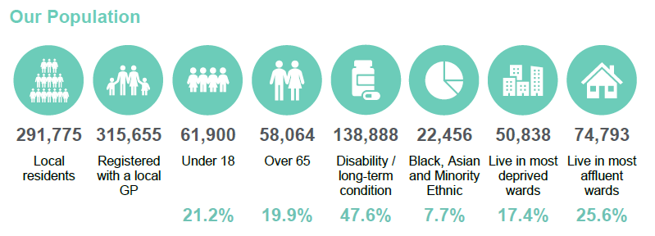

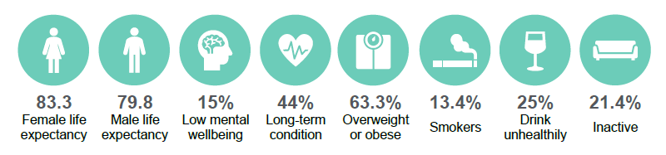

Role specification

JOB TITLE: Non-Executive Director

RESPONSIBLE TO: Trust Chair

ROLE SUMMARY:

The Non-Executive Directors work alongside the Chairman and Executive Directors of the Foundation Trust Board to advise on the development of strategy and to oversee the performance of Stockport NHS Foundation Trust.

They share responsibility with other Directors for the success of the organisation using the available resources to deliver healthcare and improve the health of local people. They will bring independent and objective judgement to bear on issues relating to the strategy, direction and performance of the hospital and its community services.

KEY RESPONSIBILITIES:

- To ensure that the Foundation Trust establishes clear objectives to deliver against the terms of the licence as a Foundation Trust in accordance with NHSE/I’s Compliance Framework and to regularly review performance against these objectives.
- To ensure that the Foundation Trust has in place governance and assurance systems to fulfil its role and meet its key duties.
- To provide independent judgement and advice to Executive Directors on corporate plans and the strategic vision of the Foundation Trust.
- To pursue the opportunities and freedoms offered by Foundation Trust status.
- To support and constructively challenge the Chairman, Chief Executive and other Directors to ensure that the Board conforms to the highest standards of corporate governance and makes appropriate decisions.
- To ensure key performance targets and goals are met.
- To uphold the values of the Trust, be an appropriate role model and to ensure that the Trust promotes equality and diversity for all its patients, staff and other stakeholders.
- To represent the Trust’s views with national, regional or local bodies or individuals and to be an ambassador for the Trust.
- To participate in committees of the Board and other key NED roles/duties, in accordance with service needs as determined by the Chairman.
- To develop relationships with, and work with the Council of Governors

5.1 Person specification

 | Essential | Desirable
Eligibility and Commitment
Ability to commit average of 4-5 days per month to Trust business; and flexibility to commit more if required for defined periods | X
You are, or are eligible and willing to become, a Member of the Trust-  - Resident in England and Wales  - Not otherwise disqualified | X
Ensure you meet the criteria for eligibility for appointment as a member of the Board of Directors including the criteria for Fit & Proper Person in accordance with NHS Improvement and CQC principles. | X
Background and Experience
Have experience of operating at a senior level or board level in a public or private sector organisation | X
Have experience in the field of people and organisational development | X
Have an awareness of the current challenges and opportunities in the National Health Service | X
Have previous service as a Non-Executive Director within the public or private sector |  | X
Have an awareness of developments in the Stockport local health economy |  | X
Are able to engage in strategic thinking and development for organisations | X
Able to demonstrate a strong connection to their local community or have lived experience, either as carers or service users. |  | X
Knowledge
Have experience of working as part of a diverse Board or equivalent to reach consensus |  | X
Have an awareness of the differing roles of a Non-Executive Director and executive management | X
Have strong emotional intelligence | X
Have an understanding of accountability for actions, including collective accountability for Board decisions | X
Have experience of engagement with a diverse and large group of stakeholders and interested parties, including the general public; and feeding that intelligence back into the work of the organisation |  | X
Have an awareness of the principles of effective corporate governance and effective Boards | X
Have an understanding of the needs of our local patient community, the roles and responsibilities of the Council of Governors, statutory and regulatory requirements, risk management and board assurance processes | X
Abilities
Capable of chairing a committee | X
You are able to participate in a unitary Board, balancing challenge and collective responsibility, to deliver statutory responsibilities | X
You are able to both support and challenge the Chief Executive and the Executive team | X
You are able to successfully engage with a range of statutory regulators and local stakeholders | X
You able to exercise judgements independently of Trust management, discuss them robustly with colleagues, and reach a final view | X
You are able to engage with and constructively challenge complex proposals and arguments | X
Good interpersonal skills. Able to work as a team to meet common goals and willingness to utilise skills and experience for the good of the organisation | X
Able to assess strategies and plans of action to achieve objectives | X

Other Information

6.1 Time commitment

The expected commitment is 4-5 days per month on average. Directors are expected to attend the Board meetings and informal Board Seminars and are likely to be appointed to sit on one or two Committees.

6.2 Induction and Training

A detailed induction programme has been developed for newly appointed Non-Executive Directors. In addition, there is access to a number of nationally-organised training events.

6.3 Remuneration

Remuneration is set at £13,000 per annum, taxed through payroll under PAYE. It is not pensionable.

The role holder would be required to Chair Board committee meetings, though this will be discussed on appointment.

Non-Executive Directors are also eligible to claim allowances, currently in line with national rates, for travel and subsistence costs necessarily incurred on Trust business.

6.4 Appointment, tenure and termination of office

Non-executive Directors are appointed for an initial period of three years, subject to a satisfactory appraisal. They are eligible to be considered for a second term, but there is no expectation of automatic re-appointment.

These posts are statutory offices, and are not subject to the provisions of employment law: a Non-Executive Director is an office-holder, not an employee. To ensure that public service values are maintained at the heart of the NHS, all Chairs and Directors of NHS Boards are required, on appointment, to agree to comply with Standards for members of NHS boards and Clinical Commissioning Group governing bodies in England, published by the Professional Standards Authority.

6.5 Criteria for Disqualification (Including Fit and proper Persons Test)

It is a statutory requirement that all Directors meet the ‘Fit and Proper Person’ test set out in Regulation 5 of the Health and Social Care Act 2008 (Regulated Activities) Regulations 2014. This requires that -
- You are of good character;
- Have the qualifications, skills and experience necessary to undertake your Trust role;
- Your health enables you (after reasonable adjustment, if required) to undertake the role;
- You have not been involved with or aware of any serious misconduct or mismanagement in relation to the provision of services regulated by the Care Quality Commission
- You are not subject to certain other matters related to bankruptcy, being on a Barred Person’s List, or having been stuck-off by a health or social care regulator.
You will be asked to self-certify your eligibility under this Regulation, and the Trust will undertake checks prior to confirming an appointment. All Directors are subject to review, at least annually, to ensure that they continue to meet these requirements.

6.7 Criteria for eligibility for appointment as a member of the Board of Directors

The following paragraphs identify the circumstances where an individual would not be eligible for appointment as a member of the Board of Directors. These are quoted directly from the Trust’s Constitution.

A person may not become or continue as a Director of the Foundation Trust if:

- They have been adjudged bankrupt or whose estate has been sequestrated and (in either case) has not been discharged;
- They have made a composition or arrangement with, or granted a trust deed for, his / her creditors and has not been discharged in respect of it;
- They have within the preceding five years has been convicted in the British Isles of any offence if a sentence of imprisonment (whether suspended or not) for a period of not less than three months (without the option of a fine) was imposed on him / her;

6.8 Checks with the Disclosure and Barring Service (DBS)

Non-executive directors may occasionally have access to children or vulnerable adults through their work for the trust. To safeguard patients by identifying unsuitable candidates, all appointments will be dependent upon satisfactory completion of a disclosure through the DBS. Checks will be carried out by the trust after the appointment and before the individual takes up their full duties.
Trust Membership

Part of the legal qualification for serving as a Non-Executive Director is that you are a formal Member of the Foundation Trust. To qualify for membership, you must-

- Be resident in England;
- Not be subject to vexatious complainant procedures at the Trust;
- Not have been dismissed from any health service body save for reason of redundancy;

The successful candidate will require to have been accepted into membership prior to assuming office.

Applying for the role

The closing date for the role is 21st August 2022.
To apply for this role, please submit an up to date copy of your CV, along with a Supporting Statement of no more than 2 pages, that addresses the criteria set out in the person specification. Please do not include photographs
You should also provide the names, positions, organisations and contact details for two referees, one of whom should be your current or most recent employer. If you do not wish us to approach your referees without your prior permission, please state this clearly.
You should submit your CV to recruitmentcentral@stockport.nhs.uk. Once you have submitted your application, you will receive an acknowledgement to confirm that we have received your application. Within the covering email, please provide your telephone and email contact details and let us know of any dates when you are not available or where you may have difficulty with the indicative timetable.

Your application will be assessed to see the extent to which you have the qualities and expertise specified for the post before it is provided to the Council of Governors Nominations Committee for consideration.
A longlisting process will take place and you may be invited to participate in a preliminary shortlisting discussion, the purpose of which will be to obtain further details about yourself, your interest in the role and to understand your skills and experience in order to inform the Council of Governors Nominations Committee as part of the shortlisting process.
It is anticipated that this preliminary process will be completed between 22nd August and 7th September 2022.
Shortlisted candidates will be informed by no later than 14th October, if they have been selected for interview and the interview details will be confirmed by email.
Formal Panel Interview will be held on the 1st November. Exact times and venue will be confirmed nearer the time. As part of the selection process you will be asked to participate in a focus group consisting of a group of Governors, Non-Executive Directors and Executive Directors in addition to the formal interview by the Nomination Committee to assess whether you can demonstrate the qualities and expertise specified. Further details will be provided nearer the time.
The Nominations Committee will recommend their preferred candidate to the Council of Governors who will make the final appointment.
The successful candidate will be contacted by the Director of People & OD.

Diversity and Monitoring

Stockport NHS Foundation Trust is committed to being an organisation within which diversity is valued and appreciated, regardless of race, age, disability, gender, sexual orientation, faith or religion and socio-economic status. The trust recognises that everyone is different, valuing their unique contribution that individual experience, knowledge and skill can make in the delivering the goals and objectives of the organisation.
The Trust undertakes monitoring of its workforce and that of its applicants and in order to ensure its effectiveness, we ask that you complete and return the monitoring form enclosed with your application form. Please note that this form will not be seen by any members of the interviewing panel.

