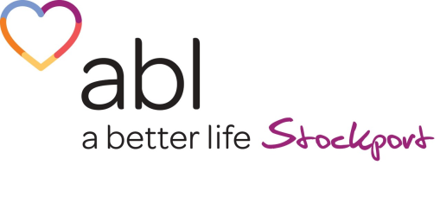

ABL Health’s partnership with BOOST programme is a Woman ONLY group designed to help the improve their lifestyle through small manageable changes and weight loss. The 12-week programme incorporates nutrition, behaviour change, exercise and goal setting to help everyone achieve what they set out to achieve.

If you would like to sign up to the programme, then please fill in details below and email to wellness.ablstockport@nhs.net

To access ABL Health, clients must meet ALL the following criteria:
Live, GP or work in Stockport □ BMI 25-35 □ Aged 18+ □

Client Personal Information (Please complete all boxes)
Mr/Mrs/Miss/Ms/Other | First Name | Surname
NHS Number (if known) | Male / Female | Date of Birth (DD/MM/YYYY)
GP Practice | PAR Q Signed off Y/N | Social Media Consent Y/N
Ethnicity | Home Phone Number | Mobile Phone Number
Email Address |  | BMI (if known)
Address
Referrers Details (Please complete all boxes) or complete self-referral box (Internal office use only)
Name | Job Title
Practice/Organisation/Department | Address
Contact Number
Contact Email
Self-Referral Yes/No (If yes please indicate where you heard about us)

