Greater Manchester’s Gender-Based Violence Strategy Consultation
Social Media Pack

Introduction
This pack includes content for social media channels to be used to promote Greater Manchester’s Gender-Based Violence Strategy consultation which is hosted on GMConsult.org.

The consultation closes at 23:59 on Sunday 1 August 2021 so please don’t use beyond then.

Launch Day
Today @greatermcr launch the consultation to gather feedback on the newly developed strategy to end gender-based violence.  Help Greater Manchester in leading the way in striving for gender equality by sharing your feedback👉gmconsult.org | 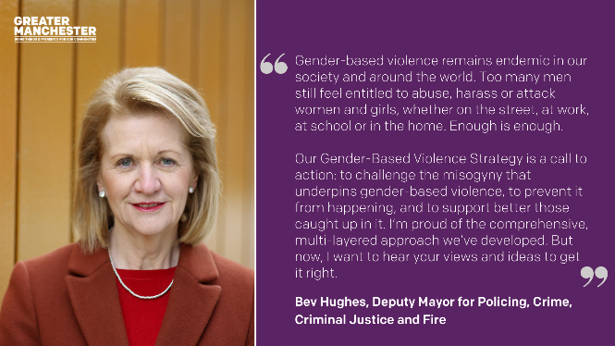  Bev1
First few weeks

We want Greater Manchester to be one of the best places in the world for women and girls to grow up, get on and grow old. That’s why we’ve created a strategy to end gender-based violence.  Share your views👉gmconsult.org | 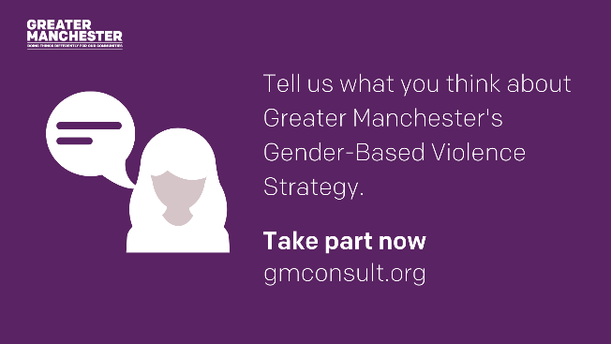  GBV.1
Got 10 minutes to play a part in ending gender-based violence in Greater Manchester?  Complete our survey to share your views on the priorities and commitments in Greater Manchester’s strategy to end gender-based violence 👉gmconsult.org | GBV.2
Greater Manchester helped to shape the modern day fight for gender equality, and continues to lead the way.  Now we want your views on our strategy to end gender-based violence.  Have your say👉gmconsult.org | 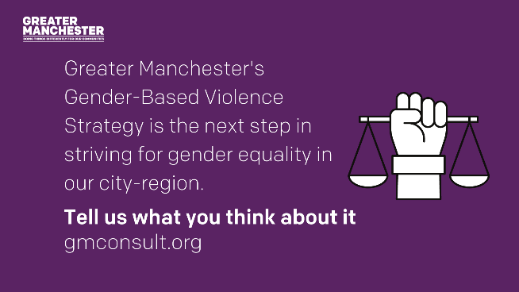  GBV.3
Greater Manchester leads the way in striving for gender equality, but some issues disproportionately impact women, like gender-based violence.  So we’ve developed a strategy to end gender-based violence and want your views on it👉gmconsult.org | 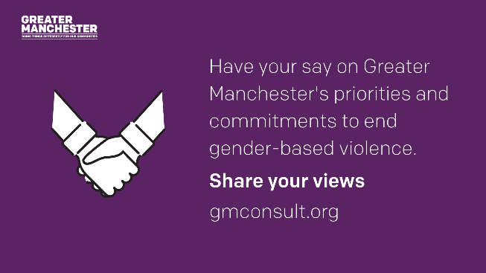  GBV.4
What do you think about our priorities to end gender-based violence?  Take part in our consultation on Greater Manchester’s Gender-Based Violence Strategy👉gmconsult.org | 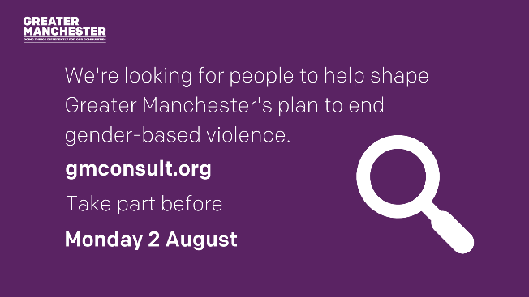  GBV.5
Have your say on our strategy to end gender-based violence.  Take part in our survey👉gmconsult.org | 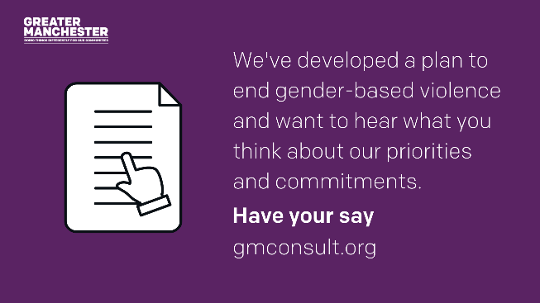  GBV.6
Greater Manchester leads the way in striving for gender equality, but some issues disproportionately impact women, like gender-based violence.  So we’ve developed a strategy to end gender-based violence and want your views on it👉gmconsult.org | 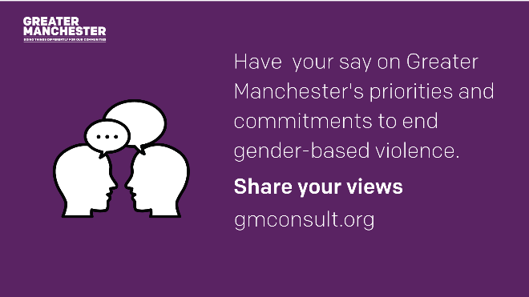  GBV.7
We’ve made a plan to prevent gender-based violence and challenge the attitudes and inequalities that enable it.  Tell them what you think about it👉gmconsult.org | GBV.8
We’ve been working with experts in our city-region and beyond to develop a set of priorities to end gender-based violence in Greater Manchester.  Now, it’s time to hear from you.  Take part in the survey👉gmconsult.org | GBV.9
We’ve developed a strategy to end gender-based violence in Greater Manchester.  Now, it’s time for you to have your say👉gmconsult.org | 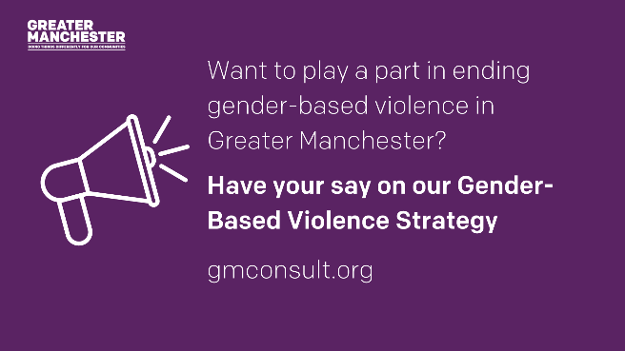  GBV.10
Let us know your thoughts on our priorities and commitments in our Greater Manchester gender-based violence strategy.  You can help shape the development.  Take part now👉gmconsult.org | 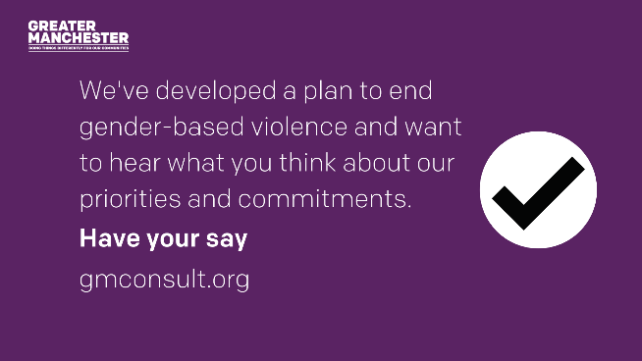  GBV.11
Few weeks to go

You have just 2 more weeks to have your say on Greater Manchester’s Gender-Based Violence Strategy.  Tell us what you think👉gmconsult.org | 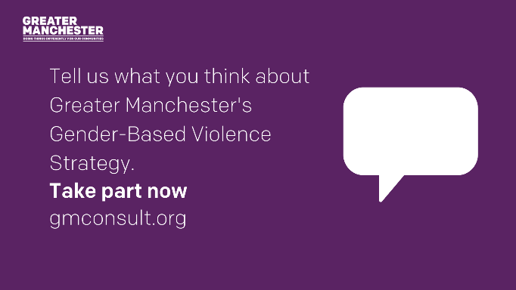  GBV.12
There’s just one week left to your say on our strategy to end gender-based violence.  Take part now👉gmconsult.org | GBV.13
There’s still time to have your say on our strategy to end gender-based violence.  The last day to have your say is Sunday 1 August  Tell us what you think👉gmconsult.org | 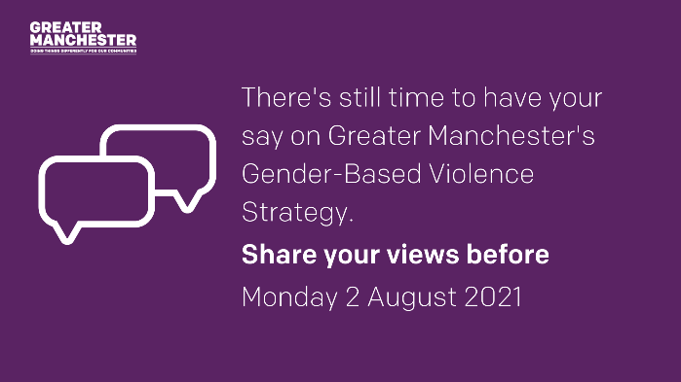  GBV.14
Last few days

There’s just a couple more days to tell us what you think about the Greater Manchester strategy to end gender-based violence.  Give your feedback at👉gmconsult.org | 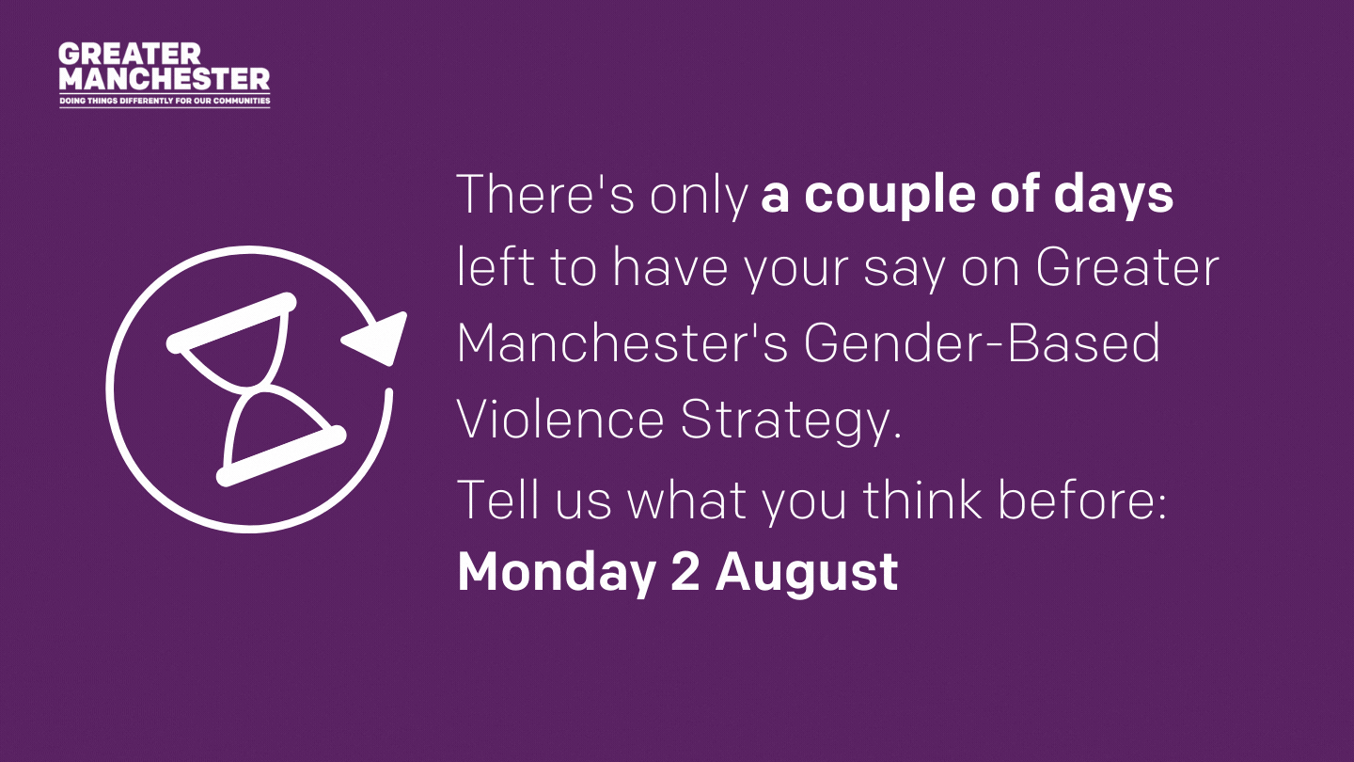  GBV.15
There’s still time to have your say on the Greater Manchester strategy to end gender-based violence but you need to hurry as consultation closes tomorrow.  Have your say👉gmconsult.org | GBV.16
Today is your last chance to help shape our Gender-Based Violence Strategy.  Share your thoughts on its priorities and commitments before midnight tonight at gmconsult.org | 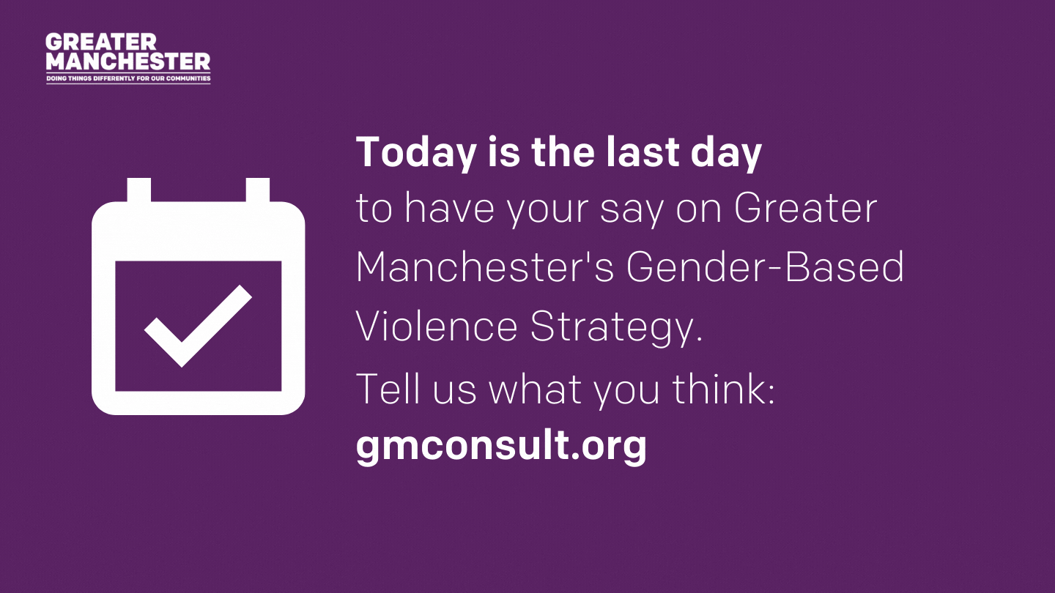  GBV.17

