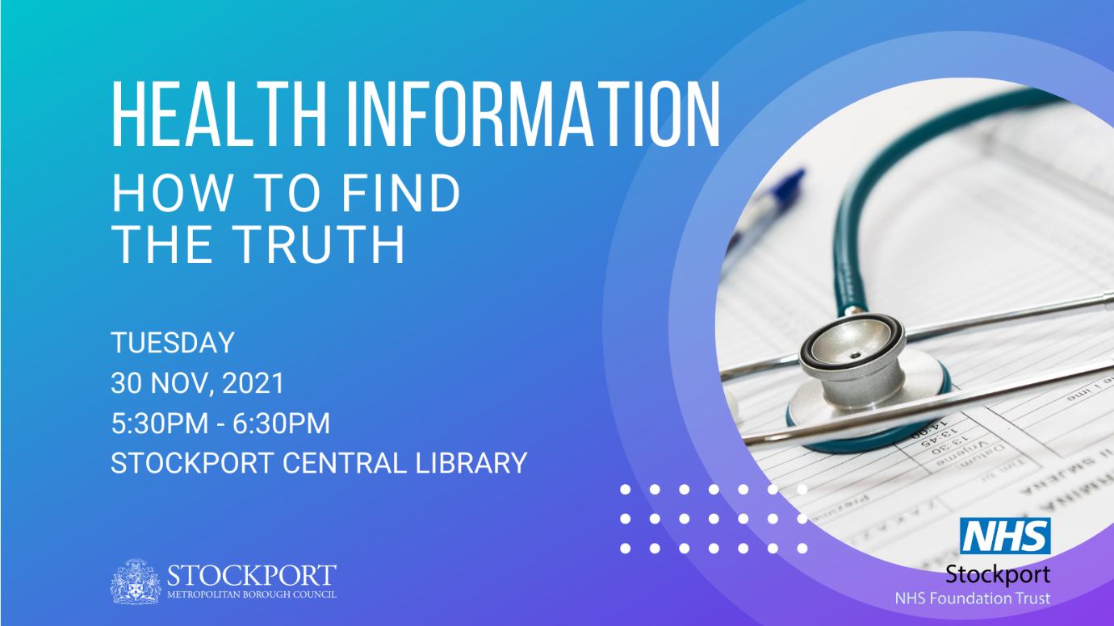

Health Information: How to Find the Truth
From vaccinations and Covid, to dieting and exercise—we are bombarded with health information these days. But not all the messages are saying the same thing.
We want to make good decisions based on accurate information, but where do we find that?
James Ryan, Health Librarian from Stockport NHS Foundation Trust, will be guiding us through the world of health information. Learn how to find and use reliable, accurate health information resources.
Tuesday, 30 November, 5:30pm-6:30pm at Stockport Central Library, SK1 3RS
The event is free, but please register your interest by email to sara.brylyn@stockport.gov.uk or by speaking with a member of library staff. Drop-ins are welcome, but we don’t want to run out of biscuits!

