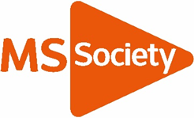  Living Well with MS |  |  | 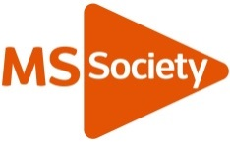
Are you recently diagnosed with Multiple Sclerosis or need more information on living well and what services and support are available across Manchester.

Saturday 23rd April 2022 from 10.30am – 2.30pm
A virtual event via Zoom

The MS Society groups across Manchester and Greater Manchester invite you to join us at this free event where we will be exploring topics such as managing fatigue, finance, the benefits of nutrition and exercise and information for family members and supporters.

There will also be opportunity to meet with your local MS group and find out what services and support they offer. Groups attending include:

• Bury and Northwest Manchester
• Bolton
• Oldham
• Rochdale
• Salford
• Stockport and South East Manchester
• Tameside and Glossop
• Trafford and South West Manchester
• Wigan and Leigh

Booking required; https://www.eventbrite.co.uk/e/living-well-with-ms-across-manchester-tickets-300788706117 : or ring 07827 281109
This event is free of charge.
MS Helpline: 0808 800 8000 (Freephone)
helpline@mssociety.org.uk - www.mssociety.org.uk
Multiple Sclerosis Society. Registered charity nos 1139257 / SC041990. Registered as a limited company in England and Wales 07451571

