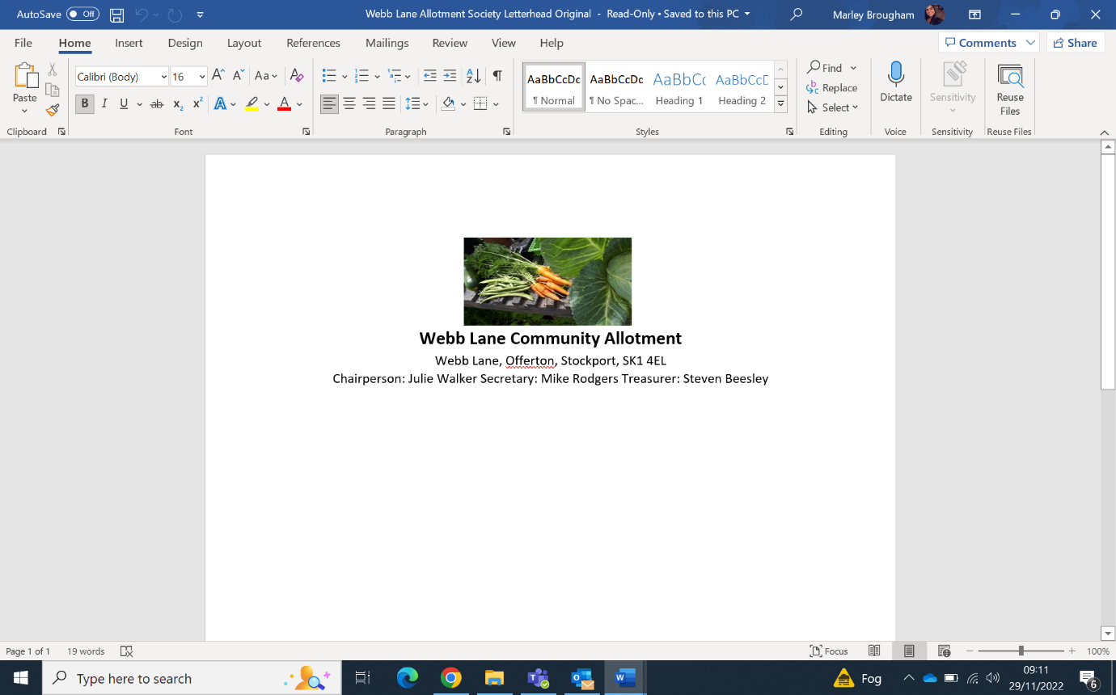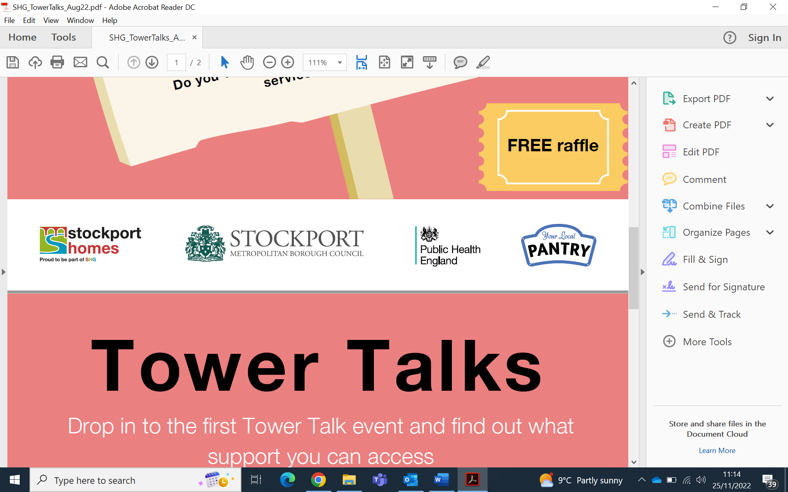

Have a chance to chat to Stockport Homes about upcoming activities in your area

Find out about other support services available to you

**at Webb Lane Allotments**

on Wednesday 21st December

at 3.00pm – 5.00pm

Public Health will be around for healthy living advice and support with your money

Hear more about growing projects and collect your FREE pot!