November 2021
Men’s Health Focused Tool Kit

Spend time with people who make you feel good

Stay connected – Your mates are important and spending time with them is good for you. Catch up regularly, check in and make time

Talk More

You don’t have to be an expert, and you don’t have to be the sole solution, but being there for someone, listening and giving your time can be life-saving

Know your numbers

At 50, talk to your doctor about prostate cancer and whether it’s right for you to have a PSA test. If you are of African or Caribbean descent or have a father or brother with prostate cancer, you should be having this conversation at 45. Know your numbers, know your risks, talk to your GP

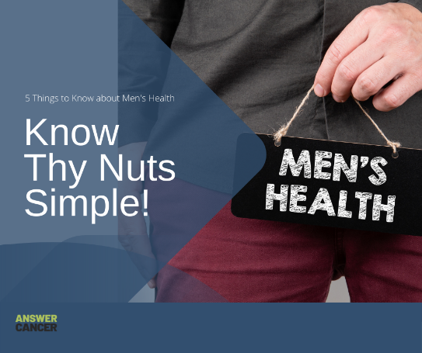 | Know thy nuts. Simple  Get to know what is normal for your testicles. Give them a check regularly, and go to the doctor is something does not feel right!  https://www.youtube.com/watch?v=cvrmnNVUvEU

Move, Move, Move

Add more activity to your day. Do more of what makes you feel good. Take a walking meetings. Park further away from work. Get off the bus a stop or two earlier instead of getting a lift. Take the stairs.

