

**Offerton Activities present**

**Singing for Memory**

***Living well with Dementia***

**at Offerton**

**Community Centre**

**Mallowdale Road, SK2 5NX**

**Every other week**

**For anyone living with dementia and their carers or relatives.**

All welcome. Meet other people and new friends.

Singing can improve your brain activity,

Well-being and mood, why not join this new

group where you can meet new people in

a friendly, fun and social environment, for

anyone living with memory loss.





• **Cuppa and a biscuit**

• **Join in the singing**

**Restarts on Wednesday 12th January 2022**

                                 **£2.50 each attendee**

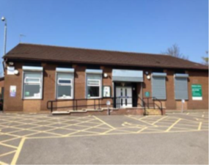

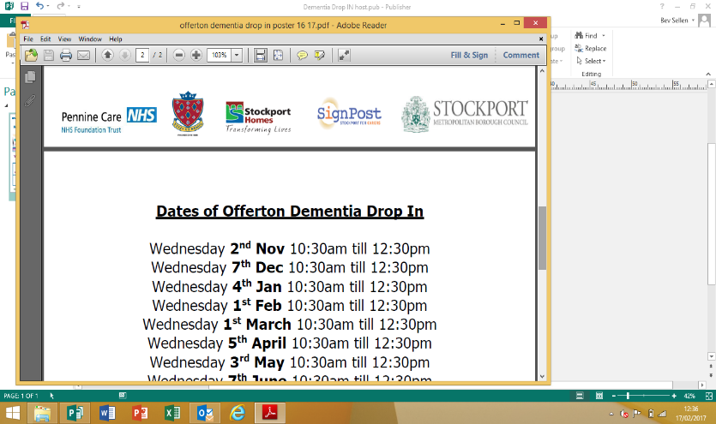

**For more information & to book a place please contact**

**Louise Evans 07875 990 222**

Every other Wednesday on the following dates:

Wednesday 12th January 2022

Wednesday 26th January 2022

Wednesday 9th February 2022

Wednesday 23rd February 2022

Wednesday 9th March 2022

Wednesday 23rd March 2022

Wednesday 6th April 2022

Wednesday 20th April 2022

Wednesday 4th May 2022

Wednesday 18th May 2022

Wednesday 1st June 2022

Wednesday 15th June 2022

Wednesday 29th June 2022

Wednesday 13th July 2022

Wednesday 27th July 2022

Wednesday 10th August 2022

Wednesday 24th August 2022

Wednesday 7th September 2022

Wednesday 21st September 2022

Wednesday 5th October 2022

Wednesday 19th October 2022

Wednesday 2nd November 2022

Wednesday 16th November 2022

Wednesday 30th November 2022

Wednesday 14th December 2022

Wednesday 11th January 2023

Wednesday 25th January 2023

Wednesday 8th February 2023

Wednesday 22nd February 2023

Wednesday 8th March 2023

Wednesday 22nd March 2023

Wednesday 5th April 2023