Pension Credit Overview

Pension Credit gives a person extra money to help with their living costs if they’re over State Pension age and on a low income. Pension Credit can also help with housing costs such as ground rent or service charges.

If someone gets Pension Credit they can also get other help, such as:
- Housing Benefit if they rent the property they live in
- Support for Mortgage Interest if they own the property they live in
- a Council Tax discount
- a free TV licence if they’re aged 75 or over
- help with NHS dental treatment, glasses and transport costs for hospital appointments
- help with their heating costs through the Warm Home Discount Scheme
- a discount on the Royal Mail redirection service if they’re moving house

When a person applies for Pension Credit their income is calculated. If they have a partner, their income is calculated together.

What Pension Credit does

Pension Credit tops up
• A person’s weekly income to £182.60 if they’re single
• A person’s joint weekly income to £278.70 if they have a partner

If their income is higher, they might still be eligible for Pension Credit if they have a disability, they care for someone, they have savings or they have housing costs.

Further detail:
Pension Credit – What You’ll Get (and see Appendix 1)

What counts as income?

A person’s income includes:
• State Pension
• Other pensions (including deferred pensions)
• Earnings from employment and self-employment
• Most social security benefits, for example Carer’s Allowance

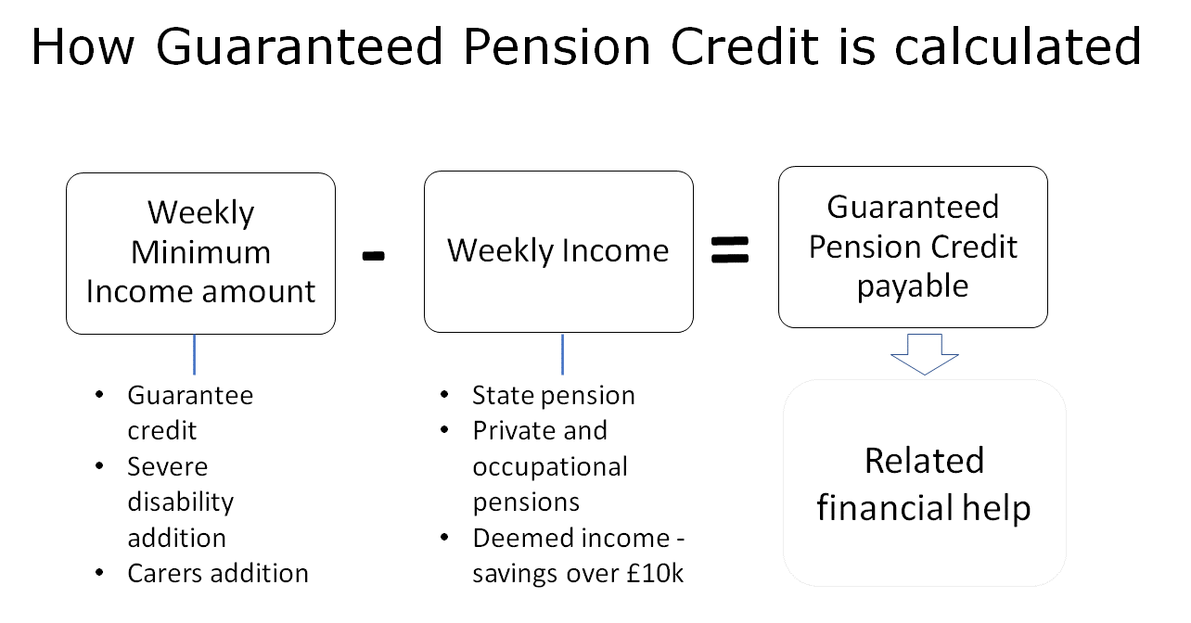

How to claim Pension Credit

Someone can start their application up to four months before they reach State Pension age.
They can apply any time after they reach State Pension age but their application can only be backdated by three months. This means they can get up to three months of Pension Credit in their first payment if they were eligible during that time.

Information required

The following information is required about the person and their partner if they have one:
- National Insurance number
- information about any income, savings and investments they have
- information about their income, savings and investments on the date they want to backdate their application to (usually 3 months ago or the date they reached State Pension age)

They will also need their bank account details. Depending on how they apply, they may also be asked for their bank or building society name, sort code and account number.

Applying online

The online service can be used if the person has already applied for their State Pension.
Apply now

Applying by phone

A friend or family member can call for the claimant if they cannot use the phone.
Pension Credit claim line
Telephone: 0800 99 1234
Textphone: 0800 169 0133
Relay UK (if the person cannot hear or speak on the phone): 18001 then 0800 99 1234
British Sign Language (BSL) video relay service if they’re on a computer - find out how to use the service on mobile or tablet
Monday to Friday, 8am to 6pm
Find out about call charges

Applying by post

To apply by post, print out and fill in the Pension Credit claim form or call the claim line to request a form.
Send the claim form to the Pension Service:
The Pension Service 8
Post Handling Site B
Wolverhampton
WV99 1AN

Recommendation
It is recommended that an application be made by phone if possible, as it is completed and the result known during the call.

Stockport Offer
For residents who require further information and/or support please contact the Stockport Support Hub (0161 474 1042) in the first instance.

