

Equipment & Information

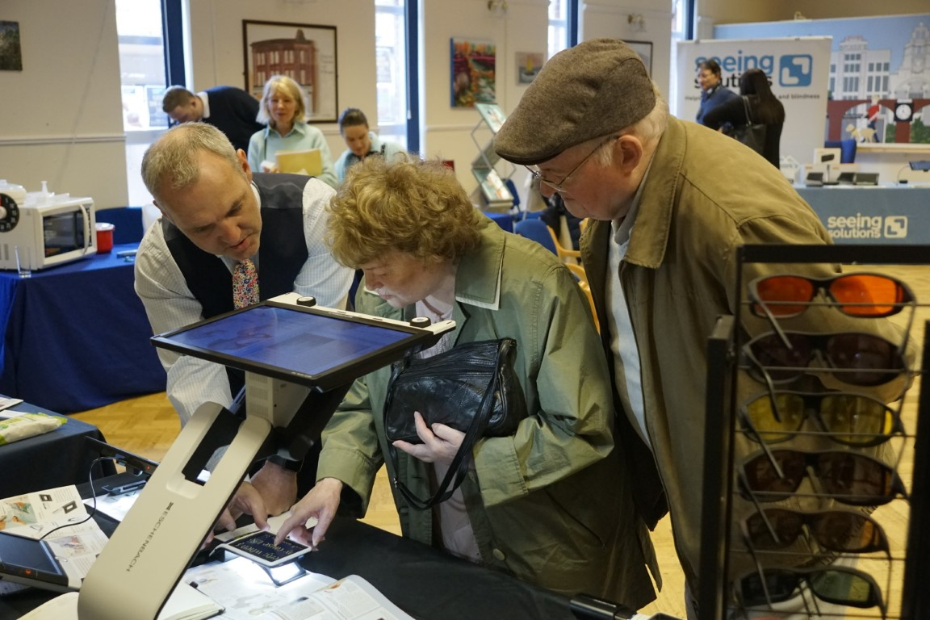
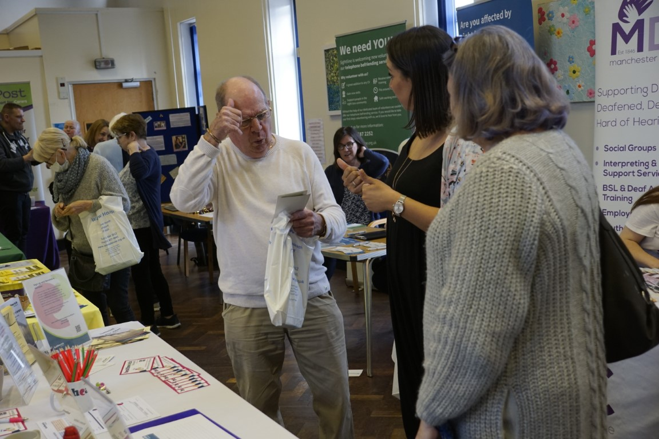
Exhibition 2023

Friday 6th October 2023
10am - 3pm

- Companies exhibiting equipment for people with a sight or hearing loss
- Organisations providing information and support for people with a sight or hearing loss

- Walthew House Resource Centre
- Refreshments
- Sighted guides and
British Sign Language interpreter

Walthew House, 112 Shaw Heath, Stockport, SK2 6QS
Phone: 0161 480 2612

Walthew House supports People in Stockport who are Blind, Visually Impaired, Deaf, Hard of Hearing or have Dual Sensory Loss. Registered Charity Number 1167749

