Shop well, Cook well, Eat well
- Would you like to learn some new cooking skills?
- Do you rely too much on convenience foods?
- Would you like to eat more healthy (and tasty) meals?
If your answer to any of the above questions is ‘YES’, then why not join us at Olive Branch on Castle Street, Edgeley, on a Friday afternoon?
Shop well, Cook well, Eat well consists of four cookery demonstrations using Food Bank ingredients. You then get to ‘taste test’ the dishes and take the recipes home to try.
Each week will include discussion on shopping, cooking and eating for health.
The group will start on Friday 29th October and sessions run from 1-3pm. Places are limited due to COVID-19 restrictions.
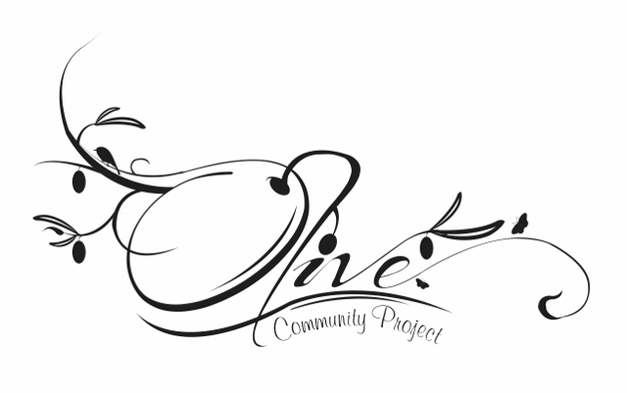
If you want to take part, please email Sharen on sharenhealth@gmail.com
phone or text us on 07759929651 or call in at Olive Branch and speak to a member of staff.
Look forward to working with you!

