SKILLS FOR PEOPLE
MANAGEMENT & DEVELOPMENT PROGRAMME
Lead with confidence Inspire with clarity
Support with empathy
Wednesday 17 December 2025

Day 1: Building the Foundations of People Management
Join us for an engaging, practical 1‐day course designed to give line managers and team leaders the tools they need to create high‐performing, motivated teams.
What you’ll gain:
A clear understanding of your role and responsibilities as a people manager.
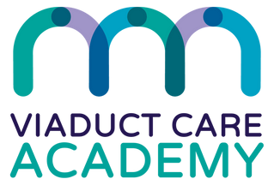
Confidence to address performance, conduct, and capability issues fairly and constructively.
£95*

per person
Member
Practices
£115*
per person
Non-
Members
Strategies for recruitment, selection, and workforce planning. Skills to set expectations, build psychological safety, and foster wellbeing.
Practical coaching techniques to support your team’s growth. Core communication principles to enhance engagement and performance.
Through interactive discussions, practical exercises and reflection, you’ll leave with the confidence to lead with purpose and empathy.
Who should attend:
All line managers and team leaders looking to strengthen their people management skills.
Wednesday 17 December 2025
9am-4.30pm - lunch & refreshments included Merseyway Innovation Centre, Stockport
Spaces are limited, secure your place today!
Book Here: https://buytickets.at/viaductcare/1956650
*Early bird prices only, until Friday 28th November 2025.
Full prices are then £115 for members; £140 for non-members.

