Day | Activity | Venue | Time | Contact
Monday | Deckchair Care welcome café  Come and join us for some fun, rest and relaxation | Elm Road Church Halls  Elm Road  Gatley  SK8 4LY | 1pm-3pm | Deckchair Care  0161 327 2894 | 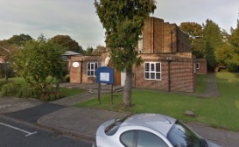
Monday  Free to attend | Memories Lane Café  Come along and enjoy complimentary coffee and cake. Chat with friends old and new and join in with fun activities | Bramhall Methodist church | Every Monday 2-4pm | Able Care Living  0161 204 7968
Monday  Free to attend | Upper Room drop-in café  Drop-in session to support each other, offer guidance and meet new people. Drinks can be bought from the cafe | Upper Rooms café  11 Wilmslow Rd Cheadle SK8 1DW | Every Monday  11am-1pm | Wellbeing Network team on 0161 804 4416 | 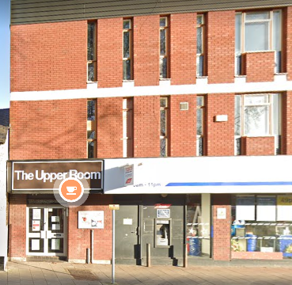
Monday | Morrisons Café meet  Come along for a chat and a cuppa | Morrisons’ Café,  Edgeley Rd, Cheadle Heath, Stockport SK3 0TQ | Every Monday  1.45pm-3.15pm | Home Instead  0161 480 0646
Monday | Drop In Café  Friendly group for people living with dementia and carers | Berretto Lounge Unit 3 Redrock, Bridgefield St SK1 1SA | Every Monday 2pm-3pm | Gill Oakes  01625 871 837
Tuesday | The Ladybrook Group  Carers and cared for support group. A friendly get together, talking, singing and dancing. Drinks and lunch can be purchased | The Ladybrook  Fir Rd, Bramhall, Stockport SK7 2NP | Every Tuesday  11.30am – 2.30pm | Emma Driver 07584 281586
Wednesday  £5 per couple | Poynton Golden Memories Group  Group run by carers of loved ones living with dementia. Peer support, laughter, enjoyment, lunch, refreshments, activities, singing, crafts | The Main Hall, Poynton Civic Centre,  Off Park Lane, Poynton, Cheshire SK12 1RB. | 11am-3pm | Judy Hatton  01625 879376 07768 160095  Or  Pauline Winfield 01625 879273 07809 371667 | 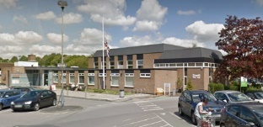
Wednesday  £4.00 per person, this includes lunch | RE: DISH Dementia Friendly Café  A friendly get together for people with dementia, their family, carers and friends. Price includes lunch | The Tapestry at St Agnes Church,  Off Gorton Rd,  North Reddish. SK5 6RA | 12pm – 2pm | Alison on 07540 792409 | 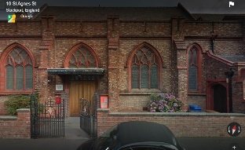
Wednesday | Stepping Hill Dementia Drop In  Jacky Smith, volunteer from the Alzheimer’s Society will be available in the lounge for a chat, advice, support and signposting. | The Serenity Lounge, Stepping Hill Hospital  Poplar Grove, Hazel Grove, Stockport SK2 7JE | 9am- 12midday | Alzheimer’s society  0161 477 6999 | 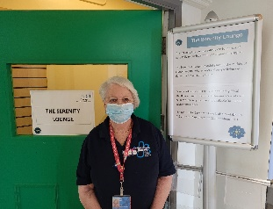
Wednesday  Group currently full. Please see Singing for Memory Group below | Alzheimer’s Society Singing for the Brain  A friendly get together for people with dementia, carers, friends; sing along to your favourite songs. | Ada Kay Resource Centre, 2a Annable Road, Bredbury, SK6 2DD | Second and fourth Wednesday  2pm-3.30pm | Alzheimer’s Society  0161 477 6999 | 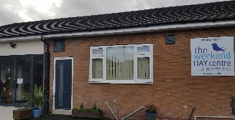
Wednesday  £2.50 per session | Singing for Memory  A new group to meet and sing with people in a fun and social environment for anyone living with memory loss | Offerton Community Centre, Mallowdale Road, Offerton, SK2 5NX | Every Fortnight on Weds starting 12/1/2022  11.30am-1pm | Stockport Homes  Louise Evans  07875 990222 | 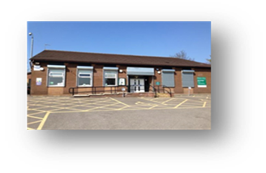
Wednesday | SK Memories Group  This will be a mix of memory activities, chair-based activities with ABL Health, and hopefully arts and crafts. | Ladybridge Connect  Off Meadway Rd, Cheadle Hulme SK8 5NZ | Every Weds  10am until 12 noon | Email:  Jamie.mccord@scfcfoundation.com  Tel 07747064924  07760454583 | 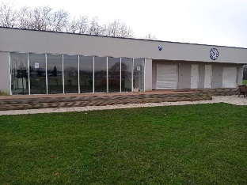
Thursday  Free to attend  Drinks can be bought from the café | ROMILEY Drop in Café Nibble & Natter  For people living with dementia, their family, carers & friends. | Romiley Life Centre,  3 Stockport Rd,  Romiley.  SK6 4BN | 3pm – 4pm | Margaret 0161 406 6729 | 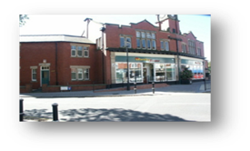
Friday  Free to attend  Hot & cold drinks at the bar | The MARPLE Drop In.  A friendly group organised by Dementia Friendly Marple and EDUCATE | Marple Cricket Club,  Bowden Lane, Marple.  SK6 6LJ | 11:30am – 1:30pm | info@marpledementiadropin.org  0161 414 0160
Friday | Stepping Hill Dementia Drop In  Jacky Smith, volunteer from the Alzheimer’s Society will be available in the lounge for a chat, advice, support and signposting. | The Serenity Lounge, Stepping Hill Hospital  Poplar Grove, Hazel Grove, Stockport SK2 7JE | 9am-3.30pm | Alzheimer’s Society  0161 477 6999
Friday  THIS GROUP IS FULL. | Fridays in HEATON MOOR  A friendly get together for people with dementia accompanied by their carer, a family member or friend. This group is operated by Dementia Friendly Heaton’s | Heaton Moor United Church,  Stanley Road,  Heaton Moor.  SK4 4HL | 1:30pm – 3:30pm | dementiafriendlyheatons@gmail.com  Contact: JoAnne on 07340 269354 | 