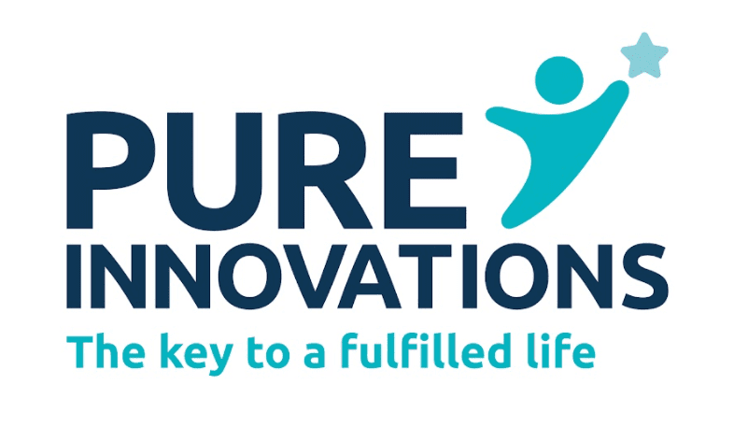
WE ARE OFFERING LI-CBT!
What is LI-CBT (Low Intensity Cognitive Behavioural Therapy)?
- Evidence suggests that LI-CBT is an effective treatment for people with common mental health problems such as anxiety disorders, depression, agoraphobia, and obsessive-compulsive disorder.
- It uses practitioners that have been specifically trained to deliver low-intensity interventions.
- LI-CBT and CBT are based on the same principle that our thoughts, feelings, and behaviours are all connected and affect each other. When people are feeling low, worried, or stressed they can get stuck in a vicious cycle. LI-CBT can help you to develop some tools to break this cycle.

What to expect:
- An assessment to determine if you will benefit from LI-CBT. If LI-CBT is not right for you, the practitioner will try to signpost you to another service.
- 6 half-hour treatment sessions via phone call or video call.
- You will have some in-between session work to complete. This is an important part of LI-CBT as the sessions are shorter than regular CBT sessions.

How to access the service:

You can find out more or request a referral form via our email:

IAPTteam@pureinnovations.co.uk

