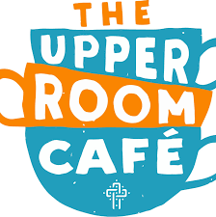
THE DROP IN
Every Monday 11am-1pm
A drop in session for people living with Dementia
and their carers!
Opening 20th September 2021

Supported by the Wellbeing Network, and
AGEUK Stockport.
A drop in café to support each other, offer guidance & meet new people!

Held at The Upper Rooms cafe Cheadle, part of St Mary’s Church. A local Community café, & a comfortable, accessible and informal setting.

For more information don’t hesitate to call the Wellbeing Network team (WIN) on 0161 804 4416
(please leave a message for a call back)

The Upper Rooms, 11 Wilmslow Rd, Cheadle, Stockport
SK8 1DW
Enter via the back of Tesco Express, next to Massie Street car park

THE DROP IN
Every Monday 11am-1pm
A drop in session for people living with Dementia
and their carers!
Opening 20th September 2021

Supported by the Wellbeing Network, and
AGEUK Stockport.
A drop in café to support each other, offer guidance & meet new people!

Held at The Upper Rooms cafe Cheadle, part of St Mary’s Church. A local Community café, & a comfortable, accessible and informal setting.

For more information don’t hesitate to call the Wellbeing Network team (WIN) on 0161 804 4416
(please leave a message for a call back)

The Upper Rooms, 11 Wilmslow Rd, Cheadle, Stockport
SK8 1DW
Enter via the back of Tesco Express, next to Massie Street car park

