Stockport Council Logo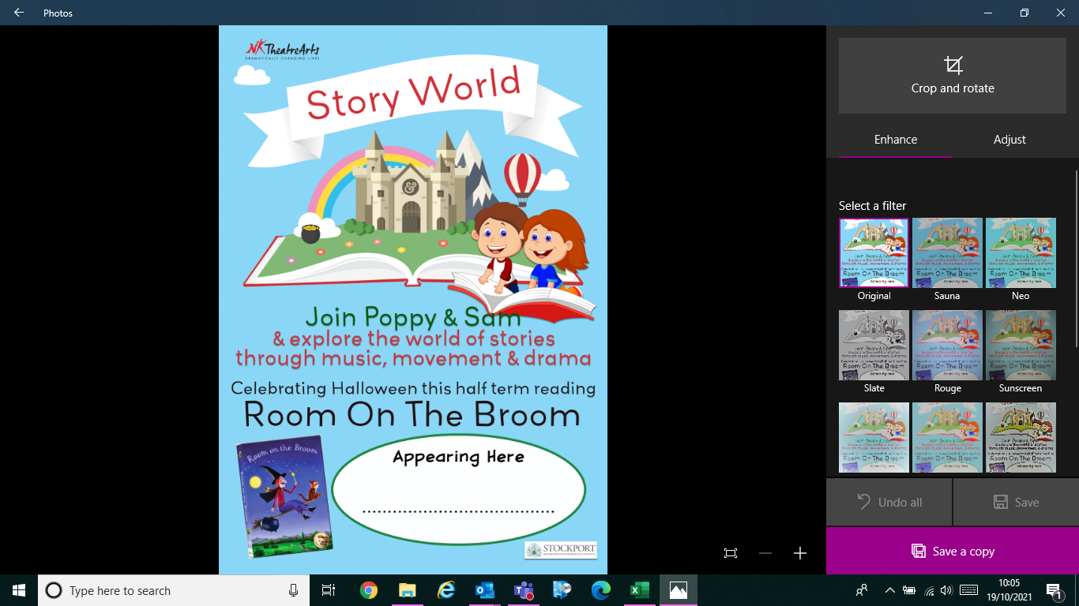

**Appearing Here**

**Date: Wednesday 27th October**

**At: Bredbury Library**

**Time: 11:00-11:30**

**Book via eventbrite to secure your place**