Stockport Council Logo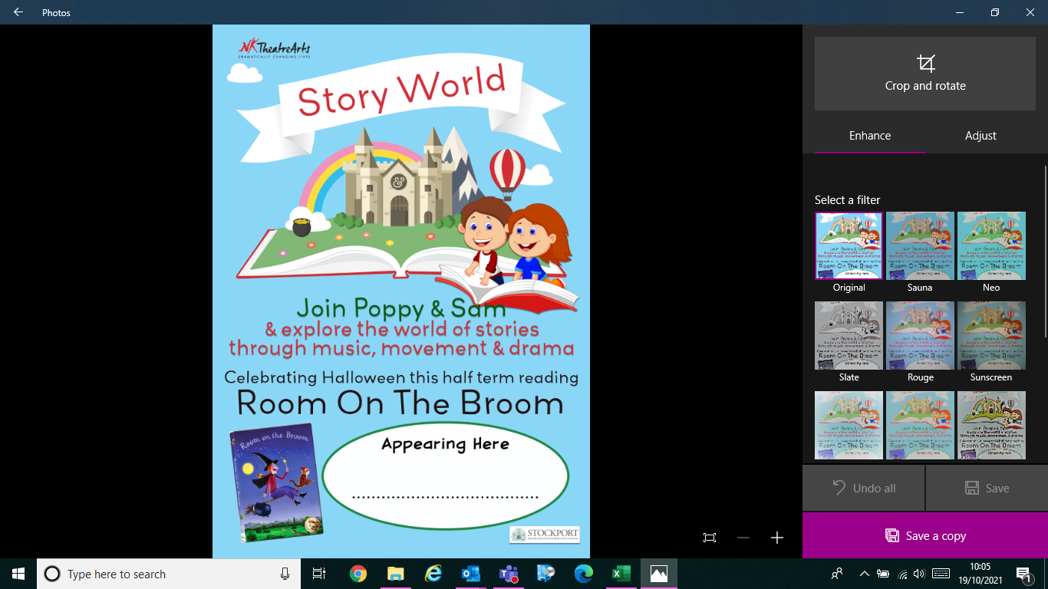

**Appearing Here**

**Date: Thursday 28th October**

**At: Marple Library**

**Time: 11:00-11:30**

**Book via eventbrite to secure your place**